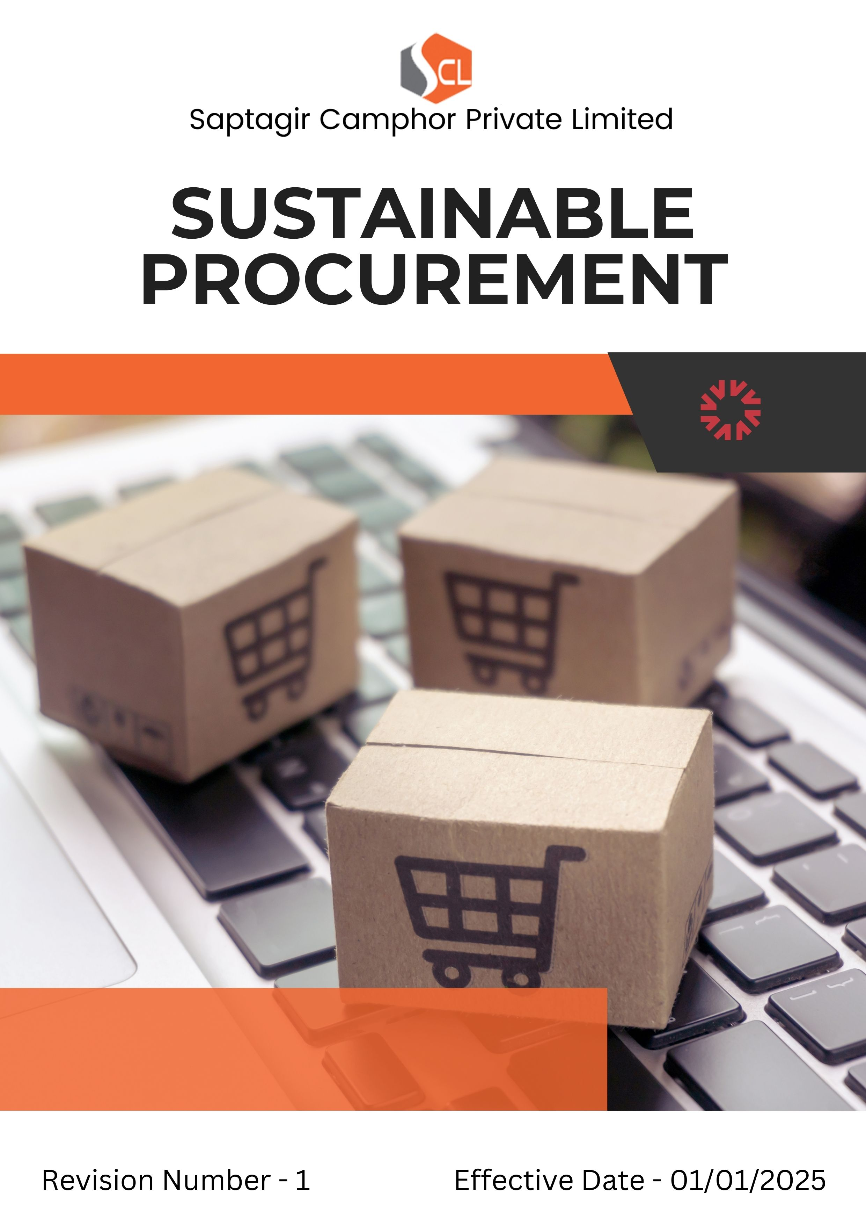

Index

❖ Introduction: 3
❖ Scope: 3
❖ Sustainable Procurement Commitment: 3
❖ Quantitative Targets: 5
❖ Action Framework: 6
❖ Roles and Responsibilities: 7
❖ Monitoring and Reporting: 8
❖ Communication and Transparency: 8
❖ Continuous Improvement: 8
❖ SDGs (Sustainable Development Goals) Covered in the Sustainable Procurement Policy 9
❖ General sustainable procurement targets: 9
❖ Review: 9
❖ Employee Acknowledgment: Sustainability Procurement Policy 11

Introduction:
Alchem International Pvt. Ltd. is committed to integrating sustainability into every aspect of its procurement practices. This Sustainable Procurement Policy outlines our approach to sourcing materials and services responsibly—emphasizing environmental protection, ethical labor practices, and long-term economic and social value. By collaborating with suppliers who share our sustainability vision, Alchem aims to minimize its environmental impact, promote fair business conduct, and contribute to a more sustainable global supply chain.

Scope:
This policy is applicable across all Alchem International Pvt. Ltd. facilities, offices, research centers, and manufacturing units, as well as all employees, workers, contractors, subcontractors, suppliers, and business partners. It also extends to the communities in which we operate, ensuring that our commitment to environmental responsibility and sustainability is embedded across our global value chain. By including our suppliers and other stakeholders, we seek to promote sustainable practices beyond our own operations and drive positive environmental and social impact throughout the industry.

Sr. No. | Address
1. | SP 2-5, RIICO Industrial Area Neemrana, 301705 Alwar, Rajasthan India
2
3
4
5
6
7
8
9

Sustainable Procurement Commitment:
Alchem International Pvt. Ltd. is committed to ensuring that all procurement activities contribute positively to the environment, society, and the local economies in which we operate. Our sustainable procurement approach is built on four core pillars that guide our sourcing and supplier engagement practices:
- Environmental Responsibility in Procurement
Alchem International strives to reduce the environmental impact of its procurement processes by partnering with suppliers who demonstrate strong environmental performance. We prioritize suppliers that:
- Use renewable, recyclable, or eco-friendly materials in their products and packaging.
- Adopt energy-efficient technologies to minimize greenhouse gas emissions.
- Implement waste reduction and responsible waste management systems.
- Ensure efficient water usage and promote sustainable water conservation practices.

- Labor Practices and Human Rights
Alchem International upholds the highest standards of labor and human rights across its supply chain. We expect our suppliers and partners to:
- Comply with all applicable labor and employment laws, including fair wages, working hours, and benefits.
- Provide a safe, healthy, and respectful work environment for all employees.
- Prohibit child labor, forced labor, and any form of human trafficking.
- Foster diversity, equity, and inclusion by ensuring fair and non-discriminatory practices.

- Ethical Sourcing and Fair Trade
Alchem International promotes ethical sourcing and supports fair-trade practices throughout its supply network. We aim to collaborate with suppliers who:
- Provide fair compensation and maintain transparent labor practices.
- Support small producers and cooperatives aligned with fair-trade standards.
- Operate with integrity, accountability, and respect for ethical business conduct.

- Supplier Engagement and Development
Alchem International believes in building long-term, responsible partnerships. We work closely with suppliers to strengthen their sustainability capabilities through:
- Regular engagement, dialogue, and feedback mechanisms.
- Capacity-building programs and technical training to improve ESG performance.
- Collaborative initiatives that drive continuous improvement and alignment with global sustainability standards.

Quantitative Targets:
- Alchem International Pvt. Ltd. establishes FY 2022–23 as the baseline year for monitoring progress in sustainable procurement initiatives and related environmental and social performance indicators.

- Environmental Sustainability in Procurement
- Ensure 75% of suppliers comply with Alchem’s environmental sustainability standards by FY 2027–28.
- Achieve a 20% reduction in supply chain carbon emissions through the procurement of energy-efficient materials and services by FY 2027–28.
- Increase the use of renewable or recycled materials by 20% across all procurement categories by FY 2027–28.

- Labor Practices and Human Rights in Procurement
- Conduct 100% audits of high-risk suppliers to verify compliance with labor laws and human rights standards by FY 2027–28.
- Ensure 100% supplier compliance with Alchem’s fair wage, safe working condition, and labor rights requirements by FY 2027–28.

- Fair Trade and Ethical Sourcing
- Ensure that at least 50% of goods sourced from developing regions meet recognized fair trade or equivalent ethical sourcing standards by FY 2027–28.

General sustainable procurement targets:
- Annual Supplier Assessments & Audits: Ensure 100% of suppliers undergo annual sustainability assessments and audits to evaluate their environmental, social, and governance (ESG) performance.
- Certified-Only Sourcing: Source 100% of goods and services from suppliers holding recognized sustainability certifications such as ISO 14001, Fair Trade, or equivalent standards.
- Supplier Capacity Building & Training: Provide annual sustainability training and resources to 100% of suppliers to strengthen their ability to meet Alchem’s environmental and social performance expectations.
- Local & Community Sourcing: Commit to sourcing 25% of goods and services from local or community-based suppliers to support regional economies and reduce the company’s overall carbon footprint.

Action Framework:
To implement its Sustainable Procurement Policy effectively, Alchem International Pvt. Ltd. follows a structured action plan emphasizing transparency, accountability, and continuous improvement:

- Supplier Assessment: Supplier Assessment: Alchem conducts detailed evaluations of suppliers’ environmental impact, labor practices, and human rights compliance through documentation reviews, site visits, and third-party certifications. These assessments ensure that all partners meet Alchem’s high ESG standards and maintain responsible business practices.

- Supplier Code of Conduct: Alchem’s Supplier Code of Conduct defines clear expectations regarding sustainability, ethical labor, and human rights. All suppliers are required to sign and comply with this code, which is periodically updated to align with global standards. Continued partnership depends on full adherence to these principles.

- Capacity Building and Collaboration: Alchem supports suppliers through training programs, workshops, and shared best practices on topics like energy efficiency, waste reduction, and fair labor. Collaborative engagement fosters mutual growth, strengthens supplier capabilities, and enhances overall supply chain sustainability.

- Regular Audits and Corrective Action: Routine audits are conducted—especially for high-risk suppliers—to monitor compliance with sustainability and ethical standards. Any non-compliance must be addressed through corrective action plans, and repeated violations may lead to suspension or contract termination. This process ensures accountability and continuous improvement across the supply chain.

Roles and Responsibilities:
- Chief Procurement Officer (CPO): The CPO holds overall responsibility for implementing the Sustainable Procurement Policy and ensuring that all procurement strategies align with Alchem International’s sustainability goals and ethical sourcing principles. The CPO also oversees the integration of ESG criteria into procurement systems and regularly reviews progress toward defined sustainability targets.

- Sustainability and Compliance Team: This team works closely with the procurement function to evaluate supplier performance, ensure compliance with sustainability standards, and coordinate regular audits. The team is also responsible for maintaining and updating Alchem’s Supplier Code of Conduct to align with evolving ESG frameworks and regulatory requirements.

- Procurement Managers: Procurement Managers are responsible for embedding sustainability requirements into all procurement decisions. They engage directly with suppliers to verify compliance with Alchem’s environmental, labor, and human rights standards and support suppliers in improving their sustainability performance where needed.

- Suppliers: Suppliers are expected to uphold Alchem International’s sustainability standards, including environmental stewardship, ethical labor practices, and responsible sourcing. They must provide transparent reporting on sustainability performance and cooperate fully with audits, assessments, and capacity-building initiatives as part of their partnership with Alchem.

Monitoring and Reporting:
- Supplier Performance Reports: Alchem International Pvt. Ltd. will prepare regular reports evaluating supplier performance against environmental, labor, and ethical standards. These reports will guide procurement decisions and help drive continuous improvement across the supply chain.
- Audit Reports: Findings from supplier audits will be reviewed by the Sustainability and Compliance Team, with any instances of non-compliance promptly addressed through corrective action plans to ensure full alignment with Alchem’s sustainability and ethical sourcing standards.
- Communication and Transparency:
- Alchem International Pvt. Ltd.’s Sustainable Procurement Policy will be published on the company’s official website and shared with all suppliers, contractors, and business partners to ensure openness and accessibility.
- Alchem will ensure that all employees involved in procurement receive regular training on sustainable procurement principles. This will empower them to make responsible sourcing decisions and engage effectively with suppliers on sustainability and ethical performance expectations.

Continuous Improvement:
Alchem International Pvt. Ltd. is committed to continuously enhancing its procurement practices to strengthen sustainability and ethical standards across the supply chain. As global sustainability priorities and market dynamics evolve, Alchem will regularly review and update its policies, collaborate closely with suppliers, and adopt innovative solutions to ensure the company remains a leader in responsible and sustainable sourcing.

SDGs (Sustainable Development Goals) Covered in the Sustainable Procurement Policy





Review:
The Sustainable Procurement Policy of Alchem International Pvt. Ltd. will be reviewed annually by the Chief Procurement Officer (CPO) in collaboration with the Sustainability and Compliance Team. The review will assess progress toward established quantitative targets, evaluate supplier performance, and ensure the policy remains effective in addressing emerging sustainability challenges and regulatory developments. Any required revisions or updates will be approved by senior management and communicated to all relevant employees, suppliers, and stakeholders to maintain alignment and transparency.

Approved By:

Designation:

Last Review Date: 01/04/2025
Next Review Date: 01/04/2026

Employee Acknowledgment: Sustainability Procurement Policy
I hereby acknowledge that I have received, read, and understood the Sustainable Procurement Policy of Alchem International Pvt. Ltd.. I recognize the company’s commitment to responsible sourcing, environmental sustainability, and ethical labor practices throughout its supply chain.
I agree to comply fully with this policy in all procurement activities, ensuring that sustainability principles guide my decision-making. I am committed to collaborating with suppliers to strengthen their sustainability practices and uphold Alchem’s environmental, social, and ethical standards. I will promptly report any concerns or potential violations related to this policy through the designated reporting channels.

Employee Name:

Employee Signature:

Date: `

